
Smart Hydration Sensor
Design Roadmap Document
ENEL 500 Capstone Design Project, Fall 2026
Team 500-MA-2-SmartH2
Project title | Smart Hydration Sensor
Team number | 500-MA-2-SmartH2
Project manager | Mizy Bermas, mizy.bermas@ucalgary.ca, UCID 30160521
Team members | Temuulen Ankhbayar, UCID 30188632  Adrian Carl Co, UCID 30174706  Jemmson Coronel, UCID 30162011  Mena El Gendy, UCID 30173978  Ahron Ramos, UCID 30173314
Support technician | To be confirmed (Jira KAN-125)
Academic advisor | Dr. Elise Fear
Sponsoring company | Garmin Canada Inc.
Sponsor representative | Jack Rovere, jack.rovere@garmin.com
Submitted | November 2026

2. Table of Contents
3. Glossary 3
4. Short Bios 3
5. Project Motivation and Objectives 4
6. Project Scope and Deliverables 5
7. Preliminary Design of the Proposed Solution 6
8. Alternative Solutions/Methodologies 11
9. IP and Other Legal Agreements 14
10. Technical Specifications 15
11. Materials, Supplies, Tools, and Cost Estimates 15
12. Risks and Risk Mitigation Plans 17
13. Major Technical Tasks and Milestones 18
14. Roles and Responsibilities 20
15. Measures of Success and Validation Tests 21
16. Team Logbook 21
17. Appendix 23
18. References 26

3. Glossary
Table 1. Terms and abbreviations.
Term | Definition
AFE | Analog front end: the IC that injects the excitation current and measures the voltage response.
BioZ / impedance | Opposition of tissue to an applied alternating current, a complex value Z = R + jX.
BIA / BIS | Bioelectrical impedance analysis (one or a few frequencies) / bioimpedance spectroscopy (a frequency sweep fitted to a model).
Tetrapolar / bipolar | Four-electrode method (separate current-drive and voltage-sense pairs) / two-electrode method where one pair both drives and senses.
Cole model, R0, R∞ | Equivalent-circuit model fitted to the sweep. R0 is the low-frequency (extracellular-dominant) resistance; R∞ is the high-frequency resistance.
ECF / ICF | Extracellular fluid / intracellular fluid.
I/Q | In-phase and quadrature parts of the demodulated response, used to get magnitude and phase.
RFDS | Relative Fluid Deficit Signal: project metric, percent change in fitted R0 from the user's personal baseline.
BFD-z | Project metric: signed, regularized distance of the current BioZ features from the personal baseline.
Confidence (Q) | Rule-based 0 to 100 measurement-quality score shown with every result. Not a probability.
Phantom | Test object with known electrical properties (resistor, RC network, or saline-agar gel).
EVKIT / DK | Vendor evaluation kit (MAX30009EVKIT) / development kit (nRF52840-DK).
MCU, BLE | Microcontroller unit; Bluetooth Low Energy.
SPI / I2C | Serial buses used between the MCU, the AFE and the sensors.
FIFO | First-in, first-out sample buffer inside the AFE.
FSM | Finite state machine that sets firmware behaviour.
CIQ | Garmin Connect IQ, the SDK for watch apps and data fields.
NCS / Zephyr | Nordic nRF Connect SDK and the Zephyr real-time operating system it is built on.
USG, BML | Urine specific gravity; body-mass loss, used as the exercise fluid-loss reference.
MVP, CFREB | Minimum viable product; Conjoint Faculties Research Ethics Board (University of Calgary).

4. Short Bios
Mizy Bermas (Electrical, Project Manager). Runs scheduling, meetings, course deliverables and contact with Garmin, Dr. Fear and the TA. Researched electrode configurations and phantom options, and owns the electrode protection schematic. Interests: project management and biomedical hardware.
Temuulen Ankhbayar (Electrical). Hardware and PCB lead. Set up the Altium workspace and component library, selected the nRF52840 and MAX30009 packages, drew the system block diagram, and built the Jira plan. Interests: PCB design, power electronics and embedded hardware.
Jemmson Coronel (Electrical). Owns the MAX30009 schematic and the electrode type, size and spacing study, and drafts the test procedures. Interests: circuit design and hands-on testing.
Mena El Gendy (Electrical). Leads AFE configuration and calibration: clock and divider settings, internal-resistor calibration and the frequency set. Leads research on BIS frequencies and hydration test experiments. Interests: biomedical signal measurement.
Adrian Carl Co (Software). Configured the nRF52840 for 1.8 V I/O and is porting the MAX30009 driver and frequency-sweep capture to Zephyr. Researched electrode spacing. Interests: embedded software and sensor integration.
Ahron Ramos (Software). Firmware lead. Wrote the Zephyr state machine, sensor drivers and CI pipeline, and owns BLE, the ethics application and the watch link. Interests: embedded systems, RTOS design and software tooling.

5. Project Motivation and Objectives

5.1 Motivation
Underhydration is common and costly. Over 65% of U.S. adults aged 51 to 70 failed basic hydration criteria, and underhydration was linked to obesity, diabetes and hypertension [1]. A 1 to 2% body-mass water loss reduces endurance and power [2] and raises the mental effort needed to stay focused [3]. Older adults also have a blunted thirst response [4]. People still have no practical way to know their own hydration level during the day.
Existing methods do not fit daily life. Plasma osmolality needs a blood draw, urine specific gravity needs a sample, and body-mass change needs weighing before and after activity [5]. Sweat sensors such as Nix and hDrop only work while the user is sweating [6], [7]. Recent pilot studies show that arm-worn bioimpedance can track whole-body water loss within one person [8], [9], [10]. No consumer wearable offers this yet, and Garmin's sensor lineup has no hydration channel [11].

5.2 Objectives
The project will build an upper-arm wearable that measures multifrequency bioimpedance, reports a quality-gated fluid trend relative to the user's own baseline, and shows it on a Garmin watch. The objectives are measurable as follows.
Table 2. Project objectives.
ID | Objective | Measurable target | Due
O1 | Measure calibrated complex impedance at multiple frequencies | ≥7 frequencies from 5 to 500 kHz; magnitude error <5% (goal <3%) and phase error <3° on known loads | Feb 5
O2 | Make the arm measurement repeatable | Within-session R0 variation (CV) <5% (goal <3%); change after removing and re-applying the device <10% (goal <5%) | Feb 26
O3 | Report a relative fluid trend, not a diagnosis | Every output carries a confidence level; 100% of injected faults (lead-off, saturation, charging) block a trend result | Mar 12
O4 | Show results on a Garmin watch | Connect IQ app shows zone, confidence, connection, battery and last-update time over BLE | Mar 12
O5 | Run as a wearable | ≥6 h continuous operation on one charge (goal ≥12 h); single 1.8 V rail; no measurement while charging | Mar 5
O6 | Keep the user safe | Injected current below the reviewed IEC 60601-1 limit in 100% of bench tests before any human test | Feb 12

6. Project Scope and Deliverables

6.1 System scope
The product is one integrated system: tetrapolar electrodes on the upper arm, a battery-powered sensor board (MAX30009 AFE and nRF52840 MCU), on-device processing, and a BLE link to a phone logger and a Garmin Connect IQ app.
The system will: run multifrequency sweeps through gel electrodes on the upper arm; calibrate and fit the data; compare it with a personal baseline; reject poor-quality readings; and send a fluid-trend category with a confidence level over BLE.
The system will not: report absolute hydration percentage or total body water, diagnose dehydration, recommend drinking volumes, or claim medical-device status. It will not be validated on a population; results are within-person pilot data [12].

6.2 Deliverables
Table 3. Deliverables by priority. Must-haves follow the MVP in the Garmin proposal [11].
Deliverable | Priority | Acceptance measure
D1. Wearable sensor prototype: custom PCB (MAX30009 + nRF52840), Li-Po battery, upper-arm strap and housing | Must | Meets Section 10 specs; ≥6 h runtime
D2. Firmware: state machine, MAX30009 SPI driver, frequency sweep, calibration, BLE service | Must | Builds with zero warnings in CI; phantom results match EVKIT within 2%
D3. Fluid-trend algorithm: Cole fit, RFDS, quality gates, confidence score, personal baseline routine | Must | Reproduces phantom values; rejects all injected faults
D4. Connect IQ app: hydration zone, connection status, last update, sensor battery, data-quality warning, calibration status | Must | All fields shown live during demo
D5. Validation reports: phantom accuracy (Stage 1) and placement repeatability (Stage 2) | Must | Pass limits in Section 15
D6. Documentation: schematics, PCB files, BOM, source code, user guide, final report | Must | Delivered to Garmin and D2L by Apr 12
D7. Motion and temperature gating (accelerometer, temperature sensor) | Should | Moving or warming trials are flagged in ≥90% of cases
D8. Controlled exercise pilot against body-mass loss (Stage 3) | Should | Ethics approval; within-person trend reported with uncertainty
D9. 12 h runtime | Should | Logged discharge test
D10. Hydration history and trends in Garmin Connect or a phone app | Nice | Daily trend view
D11. Use of Garmin heart rate / HRV for context | Nice | Shown with each reading
D12. Body composition, sweat electrolyte estimate, LLM recommendations, dry electrodes | Nice | Demonstrated only if D1 to D9 are done

Sponsor agreement and change control. The must-have list is the MVP from the proposal approved by Garmin and was reviewed with Jack Rovere at the design review check-in (Jira KAN-105). From this point, any change to scope or deliverables must be agreed by both the team and Garmin, discussed with Dr. Fear and the TA, and recorded in the logbook. Changes may not reduce the expected workload per member.

7. Preliminary Design of the Proposed Solution

7.1 System architecture
Figure 1 shows the planned wearable. The MAX30009 drives a small AC current through two outer electrodes and senses the voltage on two inner electrodes [13]. The nRF52840 configures the AFE over SPI, reads the sensors over I2C, runs the processing and sends results over BLE [14]. Every part on the board runs from one 1.8 V rail, so no level shifter is needed on the final PCB. Parts marked TBD are not selected yet.
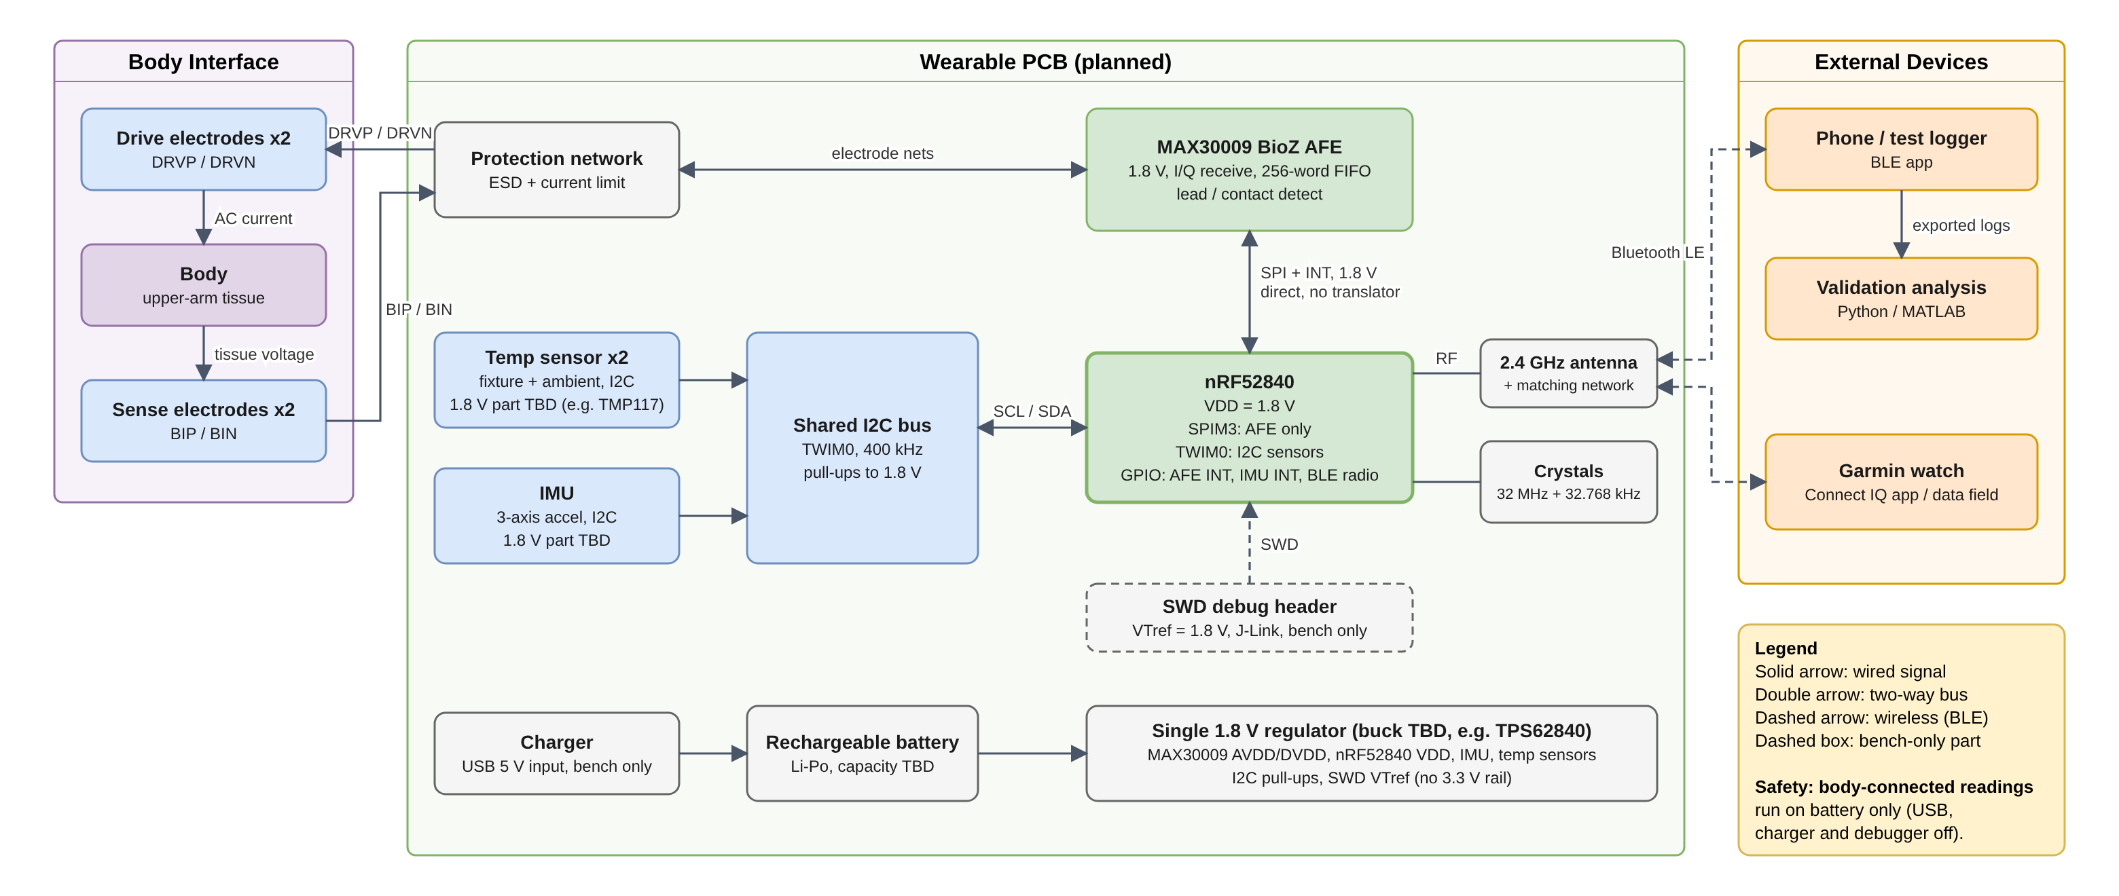
Figure 1. Detailed block diagram of the Smart Hydration Sensor (team draw.io diagram, Nov 1, 2026).
Table 4. Hardware subsystems: development hardware now, and the planned wearable PCB.
Function | Development (now) | Wearable PCB (planned) | Status
BioZ AFE | MAX30009EVKIT [15] | MAX30009ENA+T, 2 x 2 mm WLP | Selected
MCU + BLE | 2 x nRF52840-DK | nRF52840-QIAA, aQFN73 | Selected
Motion | ADXL362 breakout, SPI [16] | 1.8 V accelerometer (ADXL362 or ADXL367) | Evaluating
Temperature | 2 x MCP9808 breakout [17] | 1.8 V part, e.g. TMP117 [18] (MCP9808 needs ≥2.7 V) | Under review
Power | USB / bench | Li-Po, charger, 1.8 V buck (TPS62840 preferred [19]) | To select
Electrodes | 3M Red Dot 2560 gel Ag/AgCl | Same gel electrodes on an indexed strap | Selected
Protection | EVKIT network | ESD, AC coupling, current limiting | To design
RF and clock | On DK | Antenna + matching, 32 MHz crystal | To select

7.2 Measurement and signal processing
Figure 2 shows how the sensor, processing and user layers connect. Each reading follows a fixed order [12]:
- Sweep. Measure I/Q at each frequency (current set: 5, 10, 20, 50, 100, 200, 500 kHz) with repeated sweeps while the arm is still.
- Calibrate. Apply a per-frequency complex correction from known resistors to get calibrated Z(f) = R + jX.
- Fit. Fit the Cole model to get R0, R∞ and phase near 50 kHz [20], [21].
- Gate. Check contact, motion, temperature shift, sweat-like spectral shape, saturation and fit error, then compute confidence Q.
- Score. Compare with the stored baseline (RFDS and BFD-z) and output a category: Baseline, Slightly low, Low, Very low or Above baseline. Q below 40 shows no category.
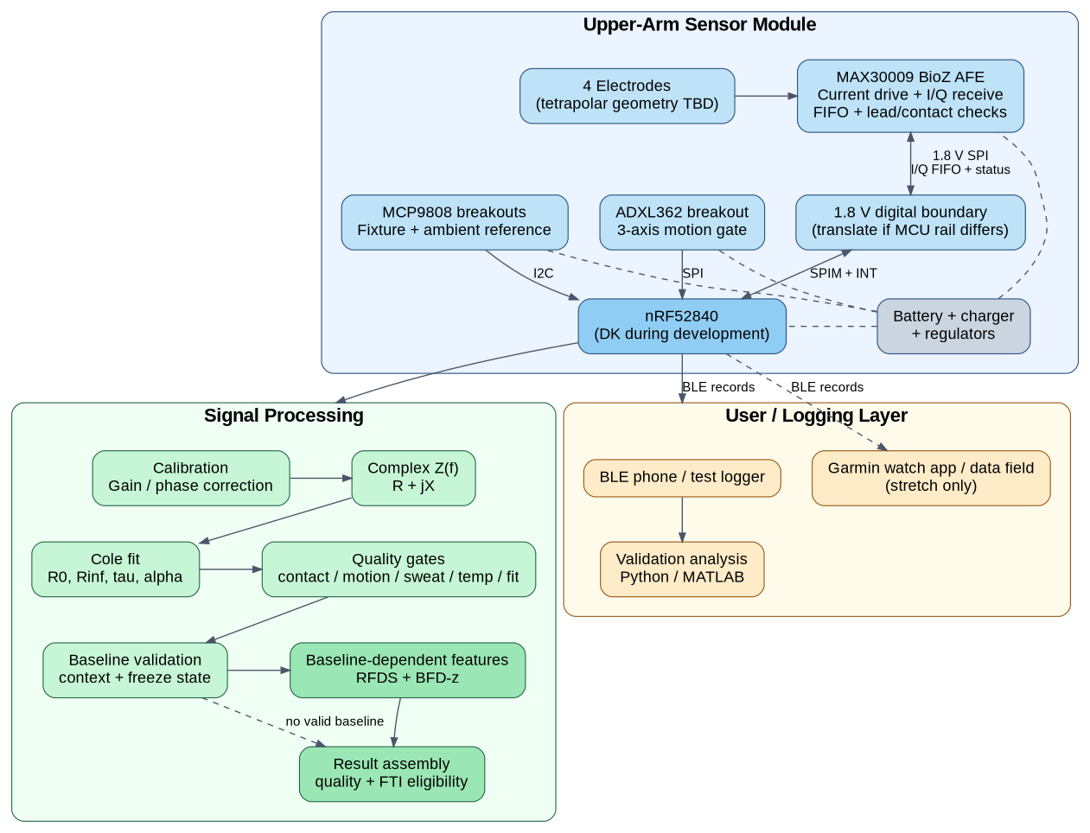
Figure 2. Sensor module, signal processing and user layers (Detailed Design [12]).

7.3 Firmware
Firmware runs on Zephyr (nRF Connect SDK v3.2.4) and is in the team repository [22]. An event-driven state machine (Figure 3) runs three regions in parallel: measurement, BLE and battery monitor. Each state has an RGB LED pattern, and a short or long button press drives pairing and fault clearing. GitHub Actions builds every pull request with warnings treated as errors and checks formatting. Measurement, BLE and battery states are implemented as stubs and will be filled as drivers are ready.
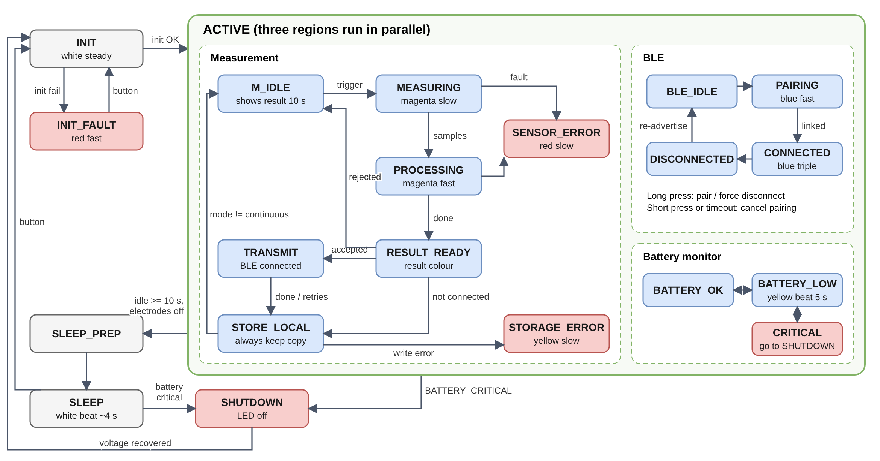
Figure 3. Firmware state machine, simplified from docs/state_machine.puml in the firmware repository [22].
Each BLE record is serialized field by field (version, session, sequence number, flags, confidence, status, RFDS, R0, R∞, phase, two temperatures, CRC-16). It is at least 41 bytes, so it is fragmented when the default 23-byte ATT MTU is in use. Rejected readings are still sent with a reject flag so failures can be counted.

7.4 Hardware bring-up path
Figure 4 shows the staged path. Phase A uses the stock EVKIT and its GUI on known loads. Phase B replaces the EVKIT controller with the nRF52840 over SPI through a 1.8 V translator, on the same sensor board and loads. The custom PCB is built only after both paths agree. Current status: internal-resistor calibration works at 50 kHz and the seven-frequency set is configured; the 10 kHz point reads wrong and is being debugged; the nRF52840 is set to 1.8 V I/O and the driver port has started (KAN-77).
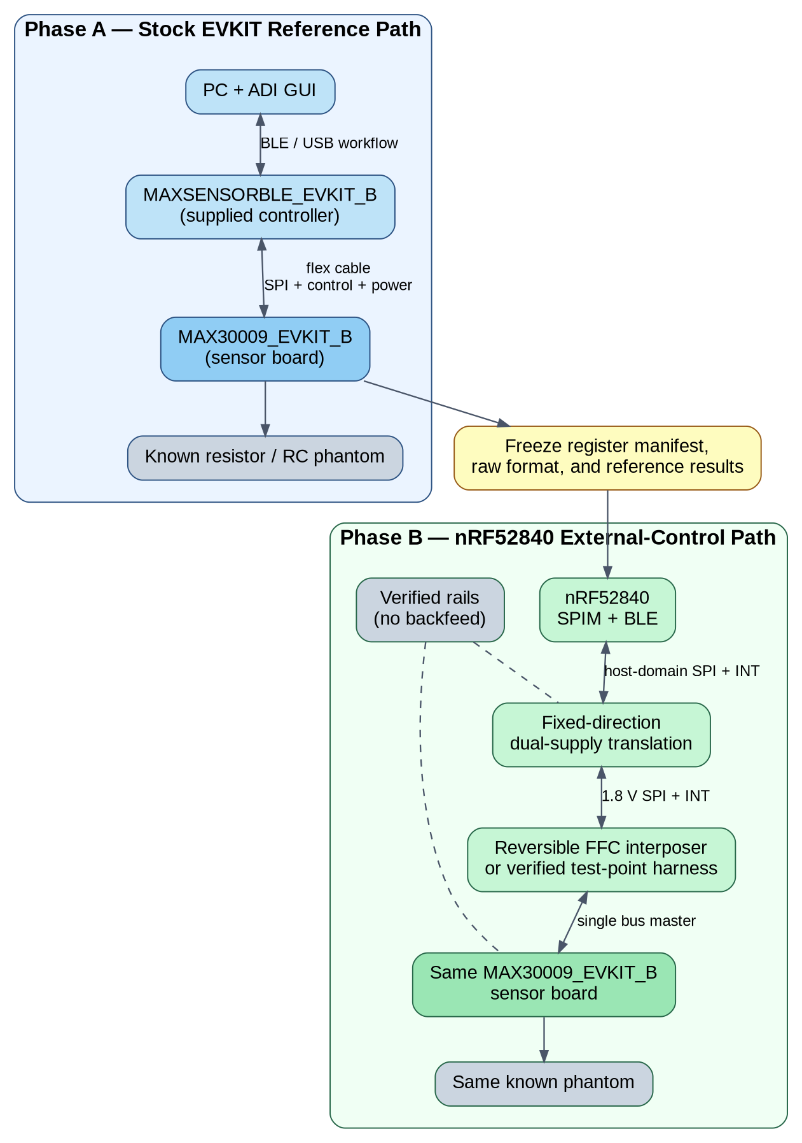
Figure 4. EVKIT reference path (Phase A) and nRF52840 external-control path (Phase B) [12].

7.5 User interface
The Connect IQ app shows the trend category first, then confidence and advice (Figure 5), plus connection, battery and last-update status. Wording stays relative ("Low vs baseline, recheck seated and still") and never says "you are dehydrated".
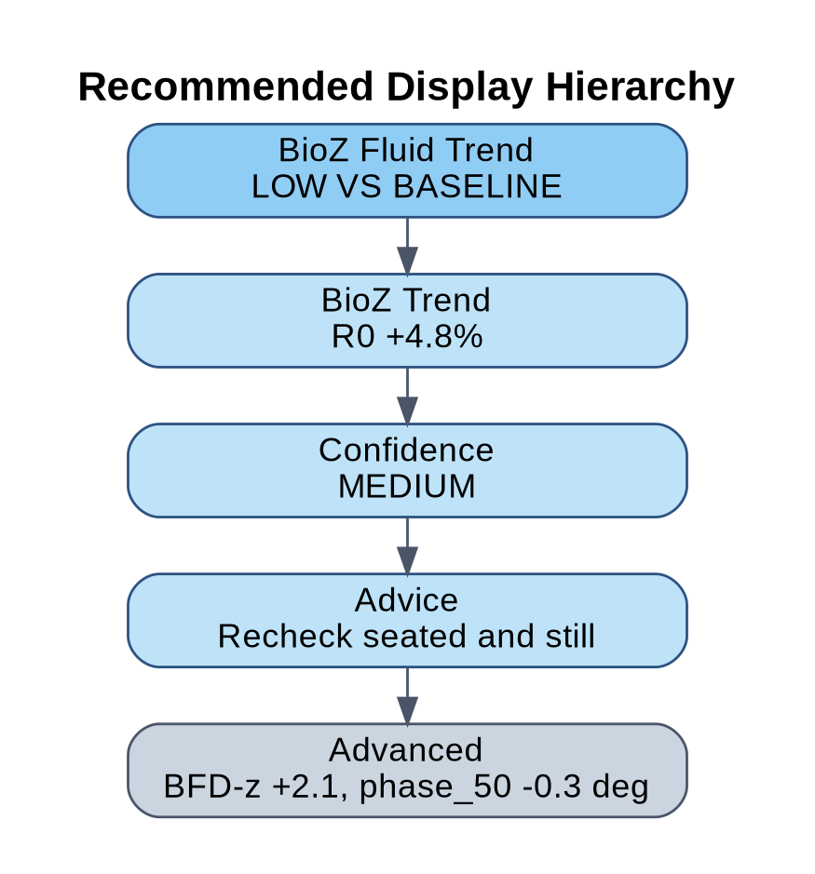
Figure 5. Planned display hierarchy for the watch app [12].

7.6 Development process
Software follows Agile with Scrum-style sprints [23]. Work is broken into Jira epics (hardware, AFE, firmware, algorithm, watch app, enclosure, validation) with owners and due dates. The three course sprints and their goals are in Section 13.

8. Alternative Solutions/Methodologies

8.1 Sensing method
Table 5. Hydration sensing methods considered.
Method | Strengths | Weaknesses | Decision
Upper-arm BIS (wearable) | Continuous, passive, non-invasive; tracked water loss in arm-worn pilots [8], [9] | Indirect; affected by motion, sweat, temperature and placement | Chosen
Sweat biosensor (Nix, hDrop) | Commercial products; sweat rate and electrolytes | Works only while sweating; no data at rest [6], [7] | Rejected
Urine specific gravity / colour | Cheap, simple | Intermittent, needs a sample, can misclassify [5] | Reference only
Body-mass change | Good acute exercise reference | Needs a scale before and after; no real-time value [5] | Validation reference
Plasma osmolality | Lab reference | Blood draw and lab | Rejected
Multi-sensor bracelet (impedance + skin hydration + temperature) | More context [24] | Wrist current path is short and superficial; more parts | Partly adopted (temperature, motion)

BIS is the only option that gives a passive reading at rest and during the day, which is the gap the sponsor asked us to fill. Its weaknesses are handled by gating and by reporting a relative trend instead of an absolute value.

8.2 Analog front end
Table 6. Bioimpedance AFE options (data sheet values).
Part | Frequency range | ADC | Supply | Fit for this project
MAX30009 (ADI) [13] | Drive 16 Hz to 500 kHz guaranteed | 20-bit, I/Q | 1.8 V | Tetrapolar BIS, lead detect, current limiter, 2 x 2 mm WLP, EVKIT available; characterized in [25]
AD5940/41 (ADI) [26] | Up to 200 kHz | 16-bit | 2.8 to 3.6 V | Proven in a wearable BIS system [27]; needs a second rail and stops at 200 kHz
AD5933 (ADI) [28] | 1 to 100 kHz | 12-bit | 2.7 to 5.5 V | Needs an external current source for tissue; low range
AFE4300 (TI) [29] | Up to about 80 kHz | 16-bit | 2.0 to 3.6 V | Built for scales; large TQFP package
MAX30001 (ADI) | Respiration BioZ | 18-bit | 1.1 / 1.8 V | No spectroscopy sweep

Choice: MAX30009. It covers the frequency range a wearable BIS fit needs [30], runs on the same 1.8 V rail as the MCU, and has the smallest package of the options. The proposal first budgeted an AD5940 board; the team switched once the MAX30009EVKIT was available. Trade-offs: the WLP package needs board-house assembly with via-in-pad, and ADI's public driver targets I2C and another MCU, so an nRF52840 SPI port is required [31]. The AD5940 remains the fallback.

8.3 Electrode configuration and placement
Tetrapolar over bipolar. In a bipolar setup the skin-electrode impedance adds directly to the reading. A tetrapolar setup senses voltage through high-impedance inputs, so contact impedance at the sense pair barely affects the result [21]. The MAX30009 supports both; tetrapolar is used.
Geometry is still open. Candidate A places the pairs across the arm, as in the arm-worn hydration study, which pushed more current through the arm [8]. Candidate B is a strip along the arm: easier to build and repeat, but more superficial. Electrode layout changes which tissue the current samples [32], and muscle is anisotropic, so orientation changes the reading [33]. The final choice will be made by the Stage 2 repeatability test (lowest R0 variation after re-application).
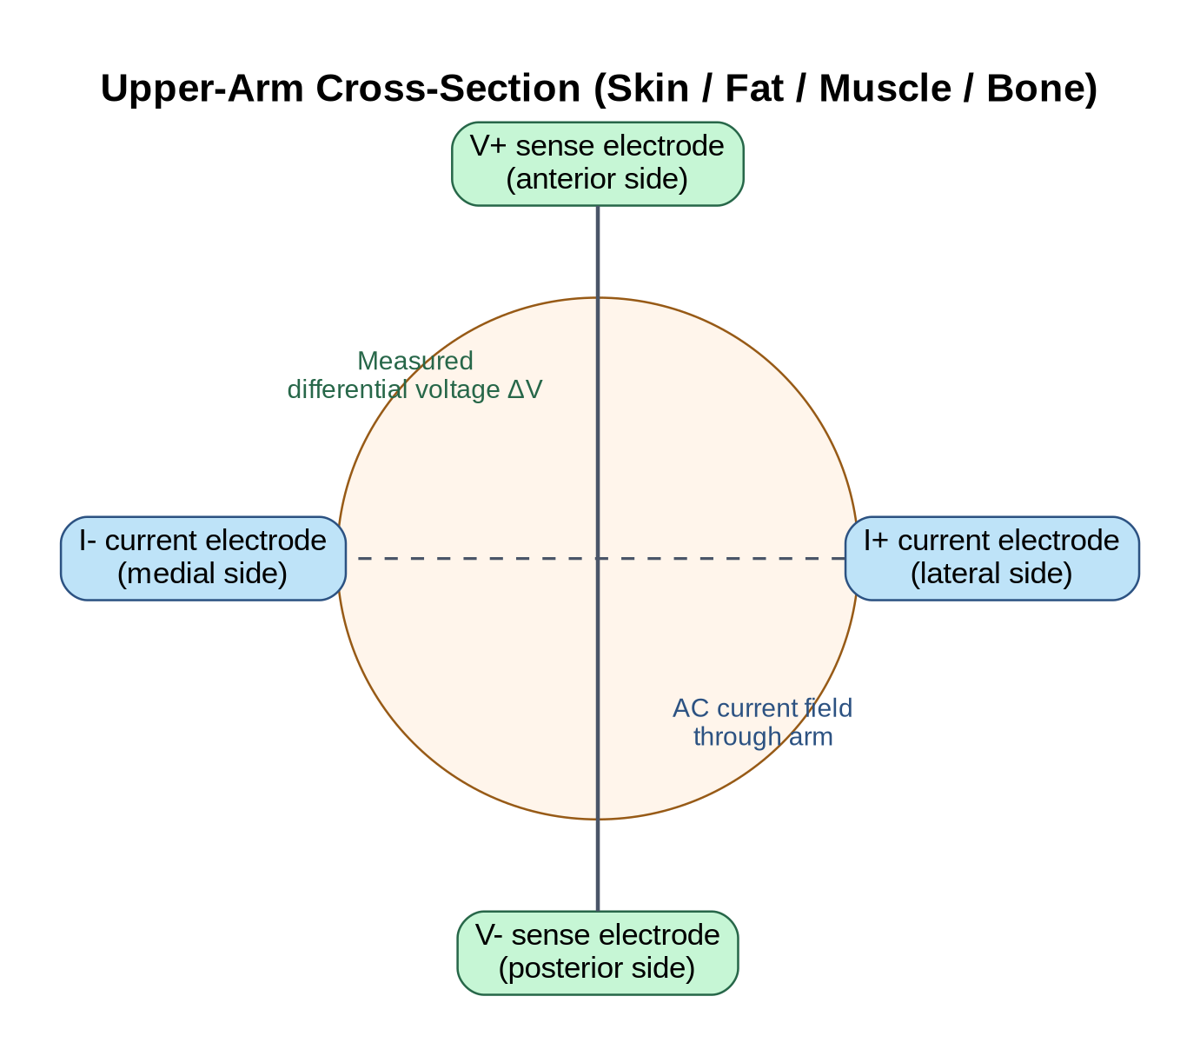
Figure 6. Candidate A, cross-arm tetrapolar placement [12].
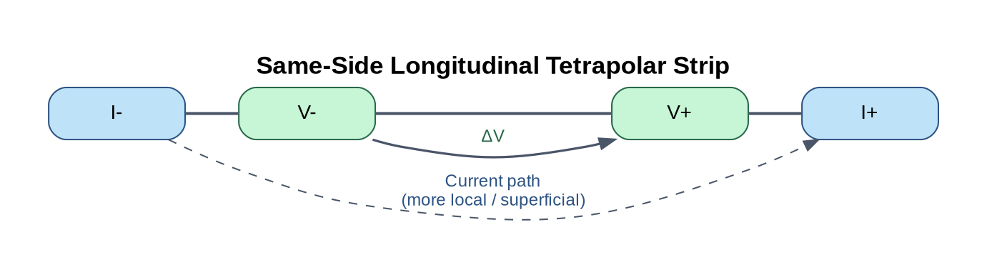
Figure 7. Candidate B, same-side longitudinal strip [12].

8.4 Validation medium
Table 7. Test media, used in this order.
Medium | Pros | Cons | Use
Precision resistors and RC networks | Exact known values | No tissue behaviour | Calibration and Stage 1 accuracy
Saline-agar gel phantom | Cheap, repeatable, tunable conductivity [34], [35] | No cell membranes, so little reactance | Electrode and fixture tests
Excised meat drying (weight reference) | Real cells; water loss measured by weight [27], [33] | Shrinks and warms as it dries | Trend check before human tests
Human volunteers | Real use case | Needs CFREB approval [36] | Stage 2 and 3 only after approval

8.5 Other design choices
Table 8. Other decisions.
Decision | Options | Chosen and why
MCU | nRF52840, nRF5340, ESP32-C3 | nRF52840: low-power BLE, DKs owned, matches the Garmin accessory ecosystem; nRF5340 adds a second core we do not need
AFE bus | SPI, I2C | SPI: deterministic FIFO burst reads and easy logic-analyzer debugging; I2C kept as fallback
Power rails | Single 1.8 V; 1.8 V + 3.3 V | Single 1.8 V: no level shifters; requires 1.8 V sensor parts
1.8 V regulator | TPS62840, TPS62240, TPS63020 (buck-boost) | TPS62840 preferred: 60 nA quiescent current, 1.8 to 6.5 V input [19]; final pick after power budget (KAN-70)
Output | Absolute hydration %; relative trend | Relative trend with confidence: absolute values are not defensible without clinical validation [8], [10]

9. IP and Other Legal Agreements
The team has signed three agreements: an intellectual property agreement with Garmin Canada Inc., a non-disclosure agreement with Garmin, and a general team contract.
Intellectual property agreement. Garmin sponsors the project and provides materials, mentorship and reimbursement for approved costs, with Jack Rovere as mentor and representative. All parties may use the work produced. Garmin keeps ownership of any technology that directly extends its own IP. After the capstone, Garmin may discuss continuing the work with the team.
Non-disclosure agreement. Each member signed an NDA covering any non-public Garmin information received or seen during the project. That information stays confidential and remains Garmin's property. Course deliverables describe only the team's own design work and public information.
Team contract. All members signed a contract setting expectations for participation, communication, workload and conflict resolution. Unresolved issues go to the academic advisor, then the TA, then the course instructor.
Issues we expect and how we handle them:
- Public firmware repository. The firmware repository is public under the MIT license [22]. Before more code is added, the team will confirm in writing with Garmin that public release is acceptable, and will keep any Garmin-provided material out of it.
- Third-party code. Reused ADI driver code [31] and Zephyr are used only under their published licenses, with attribution kept in the source.
- Participant data. Human test data will be collected only after CFREB approval, stored with anonymous IDs in the team drive, and not shared outside the team, Garmin and the advisor [36].

10. Technical Specifications
Table 9. Technical specifications. Values marked provisional will be frozen before the related test.
Parameter | Specification | Verified by
Measurement method | Tetrapolar multifrequency BIS on the upper arm | Design review
Frequency points | ≥7 points, 5 to 500 kHz (5, 10, 20, 50, 100, 200, 500 kHz) | Register readback
Impedance magnitude error | <5% (goal <3%) on 50 to 600 Ω loads | Stage 1 phantom test
Phase error | <3° on RC phantom | Stage 1 phantom test
Phantom repeatability | CV <2% (goal <1%) over 10 sweeps | Stage 1 phantom test
Arm repeatability | R0 CV <5% in one session; <10% after re-application | Stage 2 test
Excitation current | Lowest workable MAX30009 setting; below the reviewed IEC 60601-1 limit [37] in 100% of cases | Current measurement on low-impedance load
Fault handling | 100% of lead-off, saturation, FIFO and charging faults block a trend result | Fault-injection test
Measurement cadence | One stillness-gated sweep set every 5 min (provisional) | Firmware log
Output | Trend category + confidence 0 to 100; no absolute hydration % | App inspection
Wireless | BLE (nRF52840); records carry sequence number and CRC-16 | Packet decode
Display | Connect IQ app: zone, confidence, connection, battery, last update | Demo checklist
Power | Single 1.8 V rail from Li-Po; measurement disabled while charging | Schematic review, bench test
Runtime | ≥6 h continuous (goal ≥12 h) | Logged discharge test
Wearable module size / mass | ≤60 x 40 x 15 mm and ≤40 g (provisional) | Calipers, scale
Firmware quality | Zephyr / NCS v3.2.4; zero compiler warnings; formatting enforced in CI | GitHub Actions
Budget | $745 CAD approved by Garmin (Section 11) | Expense tracker

11. Materials, Supplies, Tools, and Cost Estimates

11.1 Purchased to date
Table 10. Items already purchased (Capstone Expense Tracker).
Item | Vendor | Cost (CAD) | Purpose
2 x nRF52840-DK | Digi-Key | $163.07 | MCU / BLE dev kits (primary + spare)
ADXL362 breakout | Digi-Key | $31.17 | Motion gate
2 x MCP9808 breakout | Digi-Key | $16.49 | Fixture and ambient temperature
MAX30009EVKIT | Analog Devices | $389.63 | BioZ AFE reference and bring-up
50 x 3M Red Dot 2560 electrodes | United Canada | $26.23 | Gel Ag/AgCl electrodes
Subtotal (actual) |  | $626.59

11.2 Remaining items (estimated)
Estimates include shipping and tax. Several parts are not selected yet (Appendix A), so these lines carry the most uncertainty.
Table 11. Remaining materials and supplies.
Item | Priority | Est. cost (CAD) | Basis
PCB fabrication + assembly, 2 boards (WLP needs via-in-pad) | Must | $150 | Board-house quote pending; proposal estimate $100 for one
2 x MAX30009ENA+T | Must | $53 | Digi-Key $26.72 each (Nov 1)
2 x nRF52840-QIAA-F-R7 | Must | $23 | Digi-Key $11.48 each (Oct 31)
Regulator, charger, crystals, antenna, passives (2 boards) | Must | $40 | Typical Digi-Key pricing
1.8 V accelerometer + temperature ICs (2 boards) | Must | $25 | Parts TBD
Li-Po battery | Must | $25 | Proposal estimate
1.8 V translator + FFC breakout for EVKIT to nRF wiring | Must | $20 | Needed for Phase B
Precision resistors and RC parts for phantoms | Must | $15 | KAN-82
Gel phantom: agar, deionized water, salt | Should | $54 | Amazon list ($13.99 + $39.98)
Meat samples for drying test | Should | $20 | Grocery
Strap material + 3D print filament (about 5 printer hours) | Must | $15 | Proposal
Remaining subtotal |  | $440

Estimated total: $1,067 CAD ± 15% ($626.59 spent + $440 remaining). This is about $320 over the $745 Garmin budget. Before ordering the PCB (Jan 22), the team will (1) ask Garmin for a budget increase, (2) borrow equipment listed in the proposal (watches, logic analyzer, index scale), and (3) if needed, assemble one board instead of two and use the cheaper deionized water.

11.3 Tools and resources (no direct cost)
Table 12. Tools.
Tool | Use | Source
Altium Designer + Altium 365 workspace | Schematic, PCB, component library | University license
nRF Connect SDK v3.2.4, Zephyr, VS Code, J-Link (on DK) | Firmware | Free / owned DKs
GitHub + GitHub Actions | Source control, CI builds | Free
MAX30009EVKIT GUI | AFE configuration and calibration | With EVKIT
Python / MATLAB | Cole fit, validation analysis | University license
Connect IQ SDK + simulator; 3 x AMOLED Garmin watches | Watch app | Free SDK; watches requested from Garmin (KAN-108)
Oscilloscope, logic analyzer, LCR meter, scale | Bench tests | Schulich labs / Garmin loan
3D printer (about 5 h) | Housing | Schulich makerspace
Jira, Google Drive, Discord, Teams | Logbook and communication | Free tiers

12. Risks and Risk Mitigation Plans
L = likelihood, I = impact (H, M, L). Owners review their risks at the weekly meeting.
Table 13. Project risks.
# | Risk | L / I | Mitigation | Owner
1 | Electrode placement error is larger than the fluid signal | H / H | Placement template, strap index marks, pressure control, photos; Stage 2 must pass before any pilot | Jemmson
2 | Motion, sweat or temperature distort readings | H / M | Stillness gating with accelerometer, temperature logging, spectral-shape checks, repeated sweeps | Adrian
3 | PCB or WLP assembly delayed (long lead time) | M / H | Request quotes in December, order by Jan 22, keep EVKIT + DK path as a working demo fallback | Temuulen
4 | Ethics approval late | M / H | Submit by Nov 11; continue resistor, gel and meat tests meanwhile; human stages move, not the bench work | Ahron
5 | Budget overrun (estimate is about $320 over) | H / M | Ask Garmin for an increase before PCB order; borrow equipment; one-board fallback | Mizy
6 | AFE calibration errors (10 kHz anomaly) | M / M | Test with external resistors, re-check clock and divider settings, replace the frequency if needed | Mena
7 | MAX30009 driver port takes longer than planned | M / H | Minimal driver first using ADI register code; I2C fallback; EVKIT GUI export as data path | Adrian
8 | Unsafe current through the body | L / H | Lowest current setting, AC coupling, current limit, battery-only body tests, charging lockout, advisor review | Mizy
9 | Parts not compatible with the 1.8 V rail (e.g. MCP9808) | H / L | Select 1.8 V sensor parts before schematic Rev A (Nov 20) | Temuulen
10 | Equipment damaged (one accelerometer already lost) | M / M | Check rails before connecting, ESD care, use the spare DK; report damage in the logbook | All
11 | Low availability during midterms and exams | H / M | No reviews in exam weeks, Jira due dates, buffer weeks in December and February | Mizy
12 | No lab technician confirmed | M / M | Finalize by Nov 6 (KAN-125); ask TA for contacts | Mizy
13 | Loss of a member or team conflict | L / H | Team contract escalation (advisor, TA, instructor); shared documentation so work can be reassigned | Mizy
14 | Results described as medical claims | M / M | Use wellness wording and the claim limits in Section 15 | Mena

13. Major Technical Tasks and Milestones
Dates come from the team's Jira plan. Figure 8 shows the full timeline to the end of the Winter term.
Table 14. Milestones.
Milestone | Key tasks (Jira) | Owner | Due
M1 Design roadmap submitted | KAN-41 | Mizy | Nov 8
M2 Ethics application submitted | KAN-32 | Ahron | Nov 11
M3 Schematic Rev A | MCU, AFE, power, sensors, protection (KAN-17 to KAN-24, KAN-72) | Temuulen | Nov 20
M4 Schematic review with Garmin | KAN-73 | Temuulen | Nov 24
M5 nRF52840 reads the MAX30009 | Driver, wiring, UART output (KAN-77, KAN-116 to KAN-121) | Adrian | Nov 27
M6 AFE calibrated and verified | All frequencies vs reference impedances (KAN-57, KAN-59) | Mena | Dec 4
M7 Firmware FSM + BLE link to watch | KAN-14, KAN-15, KAN-89 | Ahron | Dec 4
Fall evaluation (Sprint 1 review) | Demo M3 to M7 progress | Mizy | Nov 18 to Dec 2
M8 PCB layout done; boards ordered | KAN-74, KAN-75 | Temuulen | Jan 15 / Jan 22
M9 Algorithm prototype on recorded sweeps | Cole fit, RFDS (KAN-83, KAN-84) | Mena | Jan 22
M10 Sweep capture in firmware | R, X, |Z|, phase (KAN-78) | Adrian | Jan 29
Winter evaluation (Sprint 2 review) | Demo M8 to M10 | Mizy | Jan 25 to Feb 5
M11 Bench accuracy on resistors and phantoms | KAN-100 | Jemmson | Feb 5
M12 PCB brought up; safety verified | KAN-76, KAN-99 | Temuulen | Feb 12
M13 Repeatability, quality gating, zone thresholds | KAN-101, KAN-87, KAN-86 | Jemmson | Feb 26
M14 Battery runtime ≥6 h | KAN-102 | Temuulen | Mar 5
M15 Fluid-loss pilot vs body weight | KAN-103 (needs ethics) | Mena | Mar 12
Final demonstration + design fair | KAN-110 | All | Mar 15 to Apr 2
Final report | KAN-111 | Mizy | Apr 12

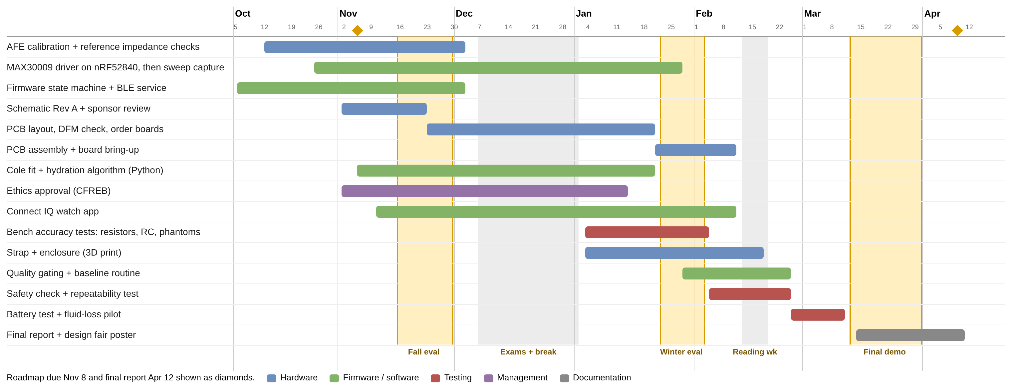
Figure 8. Project timeline from Jira due dates, with evaluation windows and exam periods.

13.1 Sprint plan
Table 15. Sprint 1 plan (Design Roadmap to Fall Term Evaluation).
Item | Sprint 1
Goals | Calibrate the EVKIT at all seven frequencies; read the MAX30009 from the nRF52840 over SPI; finish schematic Rev A; merge the FSM and define the BLE GATT service; submit ethics; confirm technician; write the V&V test plan
Outcomes | Calibration report with error table; UART log of AFE values from the nRF52840; Rev A schematic PDF; green CI build; GATT specification; ethics submission receipt
Evaluation criteria | |Z| error <5% on at least three external resistors at every frequency; part-ID readback and 10 error-free FIFO reads; schematic passes ERC and peer review; CI passes
Specs and tools | MAX30009EVKIT + GUI, nRF52840-DK, 1.8 V translator, logic analyzer, Altium, NCS v3.2.4
Cost | About $35 (translator, FFC breakout, precision resistors)
Alternatives | If SPI through the interposer fails: I2C or EVKIT GUI export. If 10 kHz stays faulty: move to a nearby frequency

Table 16. Sprints 2 and 3.
Sprint | Dates | Goals | Exit criteria | Cost
2 | Dec 2 to Feb 5 | PCB layout and order; Cole fit and RFDS in Python; firmware sweep capture; watch app connects and shows score; gel and meat tests | Boards ordered; algorithm reproduces phantom values; watch shows live data | About $400
3 | Feb 5 to Mar 15 | Board bring-up; safety check; repeatability; quality gating; enclosure and strap; battery test; pilot | Specs in Section 10 met; demo end to end | About $40

14. Roles and Responsibilities
R = responsible, A = accountable (one per row), C = consulted, I = informed.
Table 17. RACI chart.
Work package | Mizy | Temuulen | Jemmson | Mena | Adrian | Ahron
Project management, deliverables, logbook | A/R | C | C | C | C | C
Sponsor, advisor and TA communication | A/R | I | I | I | I | I
Ethics approval and safety review | A | C | C | C | I | R
AFE configuration and calibration | I | C | R | A/R | C | I
Schematic, PCB layout, bring-up, power | R | A/R | R | C | C | I
Electrodes, strap and enclosure | C | R | A/R | C | I | I
Firmware architecture, FSM, BLE | I | I | I | I | R | A/R
MAX30009 driver and sweep capture | I | C | I | C | A/R | C
Hydration algorithm and quality gating | I | I | C | A/R | R | C
Connect IQ watch app | I | I | I | I | C | A/R
Verification and validation testing | C | R | A/R | R | C | C
Final report and design fair | A/R | R | R | R | R | R

15. Measures of Success and Validation Tests
The project succeeds if every must-have deliverable (Section 6) meets its specification (Section 10) at the final demonstration. Validation runs in stages; a later stage cannot make up for a failed earlier one [12].
Table 18. Validation tests.
Stage / test | Method | Pass criterion | Objective
Stage 1: phantom accuracy | 10 sweeps each on 50, 100, 250, 500 Ω resistors and an RC phantom; EVKIT first, then nRF path | |Z| error <5%, phase <3°, CV <2%; EVKIT and nRF paths agree | O1
Safety current | Measure RMS current into a low-impedance load at every setting | Below reviewed limit in 100% of cases; any failure stops body tests | O6
Fault injection | Disconnect leads, saturate, plug in charger | 100% of faults block a trend result | O3
Stage 2: repeatability (after ethics) | 3 to 5 volunteers, 10 seated sweeps, remove and re-apply, repeat on another day | R0 CV <5%; re-application change <10%; geometry selected | O2
Stage 3: fluid-loss pilot (should) | Controlled exercise with body mass before and after | Within-person R0 trend direction matches mass loss; reported with uncertainty | O3
BLE and app | 1 h session logging sequence numbers; check every app field | Lost records counted and reported; all fields correct | O4
Runtime | Continuous logged discharge from full charge | ≥6 h | O5

Claims we will make. After Stage 1: the system measures calibrated impedance on known loads. After Stage 2: it repeatably measures upper-arm BioZ under controlled placement. After Stage 3: pilot data show a within-person trend linked to body-mass loss. If Stage 2 fails, success is a calibrated, documented measurement system with measured placement limits, and the fluid-trend display stays off.

16. Team Logbook
- Jira (HydroSense space, project KAN). Every task is a ticket under an epic, with an assignee, due date and status. Each member updates their tickets before the weekly meeting. Delays and disagreements are logged as ticket comments (Figure 9).
- Weekly meetings (Tuesday 2 to 4 PM). Recorded with Teams transcription and saved in the Meeting Transcripts folder. The PM writes minutes for advisor and sponsor meetings, and action items become Jira tickets (KAN-107).
- Google Drive. Shared folder for datasheets, research, design documents, receipts and the expense tracker (Figure 10). Members keep weekly notes (discussion points, what I did, what I will do).
- Design history. Firmware in GitHub (commits, pull requests, CI); hardware in the Altium 365 workspace.
- Scope changes. Logged in Jira with the sponsor's email approval attached.
- AI log. A Drive sheet records date, member, tool, prompt summary, output used, verification and linked ticket. The PM reviews it weekly.
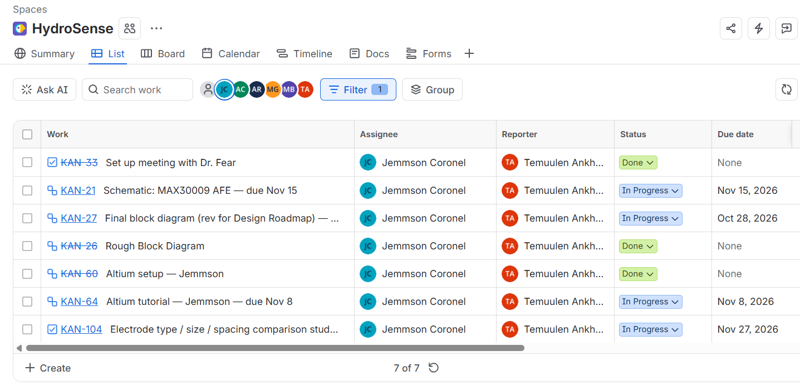
Figure 9. Jira task list for one team member (Oct 27, 2026).
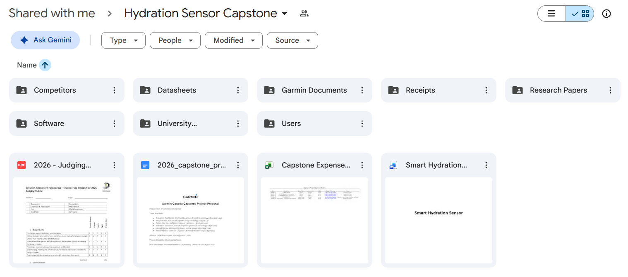
Figure 10. Hydration Sensor Capstone shared Google Drive (Oct 27, 2026).

17. Appendix

Appendix A. Component selection status (Component Index, Nov 2, 2026)
The PCB component library is still being built and several parts are not selected.
Table 19. Wearable PCB components.
# | Function | Part | Status
1 | MCU and BLE radio | Nordic nRF52840-QIAA-F-R7, aQFN73 | Selected
2 | Bioimpedance AFE | ADI MAX30009ENA+T, 25-bump WLP | Selected
3 | Accelerometer | ADXL362 (or ADXL367), order code TBD | Evaluating
4 | Skin and ambient temperature | MCP9808 needs ≥2.7 V; replace (e.g. TMP117) or add a 3.3 V rail | Under review
5 | Rechargeable battery | Li-Po, capacity TBD (≥6 h runtime) | To select
6 | Battery charger | TBD; measurement locked out while charging | To select
7 | 1.8 V regulator and DC/DC parts | TPS62840 preferred; inductors and capacitors per nRF52840 reference circuit | To select
8 | 2.4 GHz antenna and matching | Chip or PCB trace antenna, TBD | To select
9 | 32 MHz crystal | TBD | To select
10 | 32.768 kHz crystal | Optional | To select

Appendix B. Quality and artifact gating pipeline
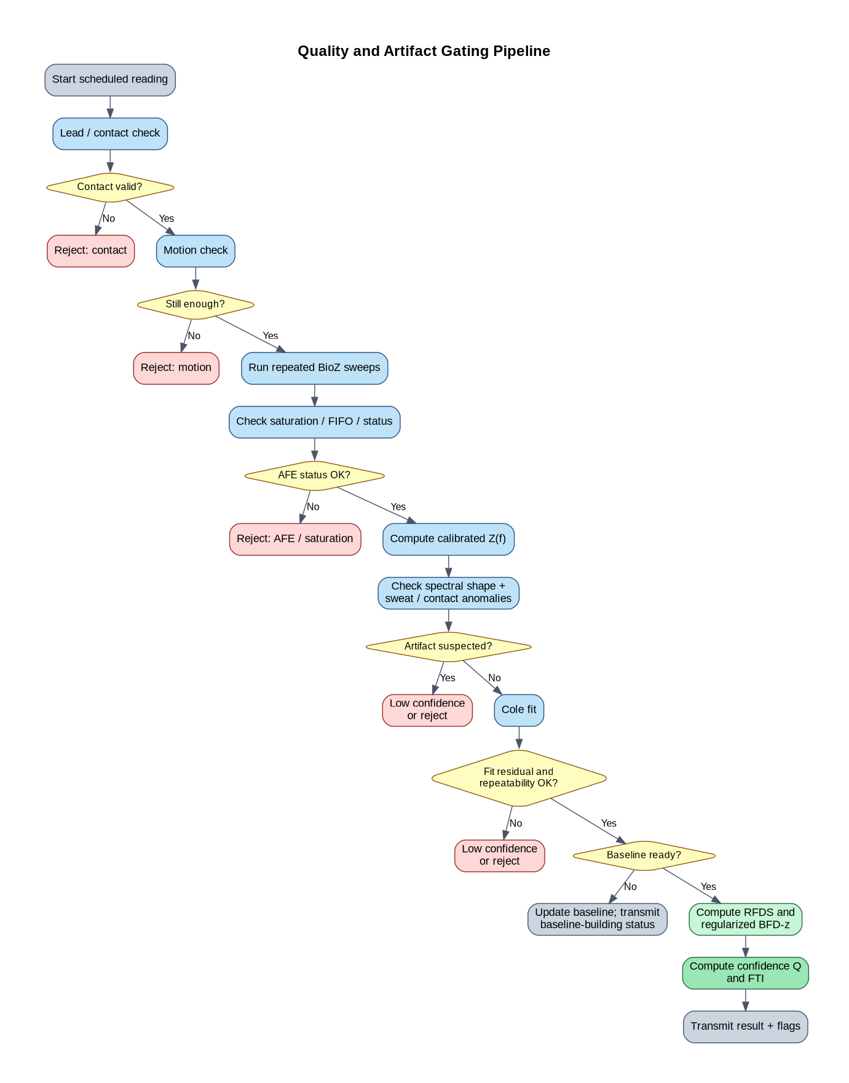
Figure 11. Quality and artifact gating applied to every reading [12].

Appendix C. Processing order
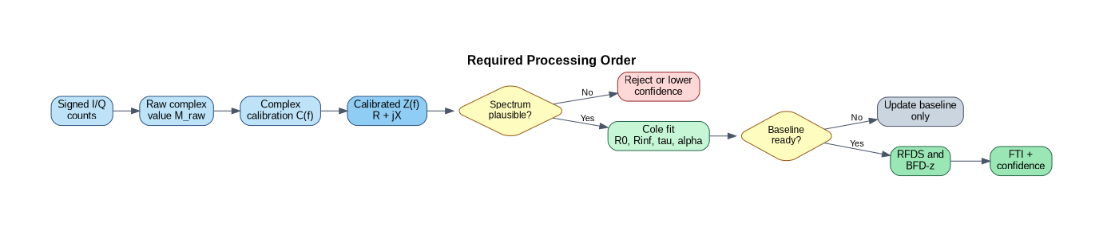
Figure 12. Required processing order from raw I/Q to the trend output [12].

Appendix D. AI Use Statement
This statement follows the ENEL 500 AI policy [38].
- Tools. Claude (Anthropic), used through Claude Code (public web service, November 2026). [Team: add any other tools and versions used on the project, e.g. the tool used to draft Jira tasks in October.]
- What it did. Organized the team's existing material into the course template, drafted wording for each section, redrew the block diagram and state machine from the team's draw.io and PlantUML files, made the timeline from Jira due dates, and checked reference details against publisher records.
- Source material. All technical content comes from the team's own documents: the draft roadmap, the Detailed Design, the proposal, the expense tracker, the Component Index, meeting transcripts, Jira tickets and the firmware repository.
- Data exposure. No Garmin confidential information was provided (the proposal lists no Garmin internal material). Team documents shared with the tool contained member names and meeting discussion only; no participant or health data exist yet.
- Verification. Each section owner checked their section against the source documents. Costs were checked against the expense tracker and Digi-Key prices, specifications against the data sheets and the Detailed Design, and every reference against the publisher or DOI record. The team is responsible for all content.
- AI log. This use is recorded in the team AI log (Section 16).

18. References
[1] J. D. Stookey, S. A. Kavouras, H. Suh, and F. Lang, "Underhydration is associated with obesity, chronic diseases, and death within 3 to 6 years in the U.S. population aged 51-70 years," Nutrients, vol. 12, no. 4, p. 905, 2020, doi: 10.3390/nu12040905.
[2] L. J. James et al., "Hypohydration impairs endurance performance: A blinded study," Physiol. Rep., vol. 5, no. 12, e13315, 2017, doi: 10.14814/phy2.13315.
[3] N. A. Masento et al., "Effects of hydration status on cognitive performance and mood," Br. J. Nutr., vol. 111, no. 10, pp. 1841-1852, 2014, doi: 10.1017/S0007114513004455.
[4] P. A. Phillips et al., "Reduced thirst after water deprivation in healthy elderly men," N. Engl. J. Med., vol. 311, no. 12, pp. 753-759, 1984, doi: 10.1056/NEJM198409203111202.
[5] B. P. McDermott et al., "National Athletic Trainers' Association position statement: Fluid replacement for the physically active," J. Athl. Train., vol. 52, no. 9, pp. 877-895, 2017. [Online]. Available: https://pmc.ncbi.nlm.nih.gov/articles/PMC5634236/
[6] Nix, Inc., "Nix Hydration Biosensor." [Online]. Available: https://www.nixbiosensors.com
[7] hDrop Technologies, Inc., "hDrop Sweat Sensor." [Online]. Available: https://www.hdrop.com
[8] M. Jankovic et al., "Wireless arm-worn bioimpedance sensor for continuous assessment of whole-body hydration," Proc. Natl. Acad. Sci. USA, vol. 122, no. 29, e2504278122, 2025, doi: 10.1073/pnas.2504278122.
[9] M. Jankovic, S. Kang, S. Bhattacharya, J. Kashanchi, T. Huang, J. Wang, E. Coyle, and N. Lu, "Wireless wearable e-tattoo for tracking dehydration," in Proc. IEEE 20th Int. Conf. Body Sensor Networks (BSN), Chicago, IL, USA, 2024, pp. 1-4, doi: 10.1109/BSN63547.2024.10780697.
[10] V. Leonov, S. Lee, A. Londergan, R. A. Martin, W. De Raedt, and C. Van Hoof, "Bioimpedance method for human body hydration assessment," in Proc. 41st Annu. Int. Conf. IEEE Eng. Med. Biol. Soc. (EMBC), Berlin, Germany, 2019, pp. 6036-6039. [Online]. Available: https://ieeexplore.ieee.org/document/8857207
[11] Team 500-MA-2-SmartH2, "Garmin Canada capstone project proposal: Smart Hydration Sensor," University of Calgary, 2026.
[12] Team 500-MA-2-SmartH2, "Smart Hydration Sensor: Detailed design," internal design document, University of Calgary, Oct. 2026.
[13] Analog Devices, "MAX30009: Low-power, high-performance bioimpedance analog front-end," Data sheet, Rev. 2, 2023. [Online]. Available: https://www.analog.com/media/en/technical-documentation/data-sheets/MAX30009.pdf
[14] Nordic Semiconductor, "nRF52840 product specification." [Online]. Available: https://docs.nordicsemi.com/r/bundle/ps_nrf52840/page/keyfeatures_html5.html
[15] Analog Devices, "MAX30009EVKIT evaluation kit," User guide. [Online]. Available: https://www.analog.com/media/en/technical-documentation/data-sheets/max30009evkit-evk-rev2.pdf
[16] Analog Devices, "ADXL362: Micropower, 3-axis, ±2 g/±4 g/±8 g digital output MEMS accelerometer," Data sheet. [Online]. Available: https://www.analog.com/media/en/technical-documentation/data-sheets/adxl362.pdf
[17] Microchip Technology, "MCP9808 ±0.5 °C maximum accuracy digital temperature sensor," Data sheet DS20005095. [Online]. Available: https://www.microchip.com/en-us/product/mcp9808
[18] Texas Instruments, "TMP117: High-accuracy, low-power, digital temperature sensor," Data sheet. [Online]. Available: https://www.ti.com/product/TMP117
[19] Texas Instruments, "TPS62840: 1.8-V to 6.5-V, 750-mA, 60-nA IQ step-down converter," Data sheet. [Online]. Available: https://www.ti.com/product/TPS62840
[20] D. Ayllón, F. Seoane, and R. Gil-Pita, "Cole equation and parameter estimation from electrical bioimpedance spectroscopy measurements: A comparative study," in Proc. IEEE EMBC, 2009. [Online]. Available: https://ieeexplore.ieee.org/document/5334494
[21] S. F. Khalil, M. S. Mohktar, and F. Ibrahim, "The theory and fundamentals of bioimpedance analysis in clinical status monitoring and diagnosis of diseases," Sensors, vol. 14, no. 6, pp. 10895-10928, 2014. [Online]. Available: https://pmc.ncbi.nlm.nih.gov/articles/PMC4118362/
[22] A. Ramos et al., "hydration-sensor: nRF52840 firmware for the Smart Hydration Sensor," GitHub repository, 2026. [Online]. Available: https://github.com/ramos-ahron/hydration-sensor
[23] Agile Alliance, "Agile 101." [Online]. Available: https://www.agilealliance.org/agile101/
[24] S. Tonello et al., "Design and in vitro characterization of a wearable multisensing system for hydration monitoring," IEEE Trans. Instrum. Meas., vol. 73, 2024, doi: 10.1109/TIM.2024.3369161.
[25] H. Crandall, A. Burt, and B. Sanchez, "Characterization of the Analog Devices Inc (ADI) MAX30009 bioimpedance analog front end chip," in Proc. 44th Annu. Int. Conf. IEEE Eng. Med. Biol. Soc. (EMBC), Glasgow, U.K., 2022, pp. 2502-2505. [Online]. Available: https://ieeexplore.ieee.org/document/9872000
[26] Analog Devices, "AD5940/AD5941: High precision, impedance, and electrochemical front end," Data sheet. [Online]. Available: https://www.analog.com/media/en/technical-documentation/data-sheets/ad5940-5941.pdf
[27] Y. Zhu, A. Bozkurt, W. D. Reynolds Jr., S. Wu, and T. P. Songkakul, "Wearable bioimpedance monitoring system using conformal nanowire electrodes," U.S. Patent Application 2023/0136435 A1 (granted as U.S. Patent 12,697,039). [Online]. Available: https://patents.justia.com/patent/20230136435
[28] Analog Devices, "AD5933: 1 MSPS, 12-bit impedance converter, network analyzer," Data sheet. [Online]. Available: https://www.analog.com/media/en/technical-documentation/data-sheets/AD5933.pdf
[29] Texas Instruments, "AFE4300: Low-cost, integrated analog front-end for weight-scale and body-composition measurement," Data sheet. [Online]. Available: https://www.ti.com/product/AFE4300
[30] B. Ibrahim, D. A. Hall, and R. Jafari, "Bio-impedance spectroscopy (BIS) measurement system for wearable devices," in Proc. IEEE Biomed. Circuits Syst. Conf. (BioCAS), 2017.
[31] Analog Devices, "MAX30009 no-OS driver" and "MAX32655-to-MAX30009 SPI example." [Online]. Available: https://analogdevicesinc.github.io/no-OS/drivers/afe/max30009.html and https://github.com/analogdevicesinc/MAX32655_MAX30009
[32] M. Jafarpoor, J. Li, J. K. White, and S. B. Rutkove, "Optimizing electrode configuration for electrical impedance measurements of muscle via the finite element method," IEEE Trans. Biomed. Eng., vol. 60, no. 5, pp. 1446-1452, May 2013.
[33] K. I. Suarez Perez, D. S. Apatiga Perez, A. H. Dell'Osa, and M. Ramirez-Barrios, "Anisotropy properties of chicken muscle tissues with bioimpedance measurements via AD5933EBZ," in Proc. 18th Int. Conf. Elect. Eng., Comput. Sci. Autom. Control (CCE), Mexico City, Mexico, 2021, pp. 1-6, doi: 10.1109/CCE53527.2021.9633096.
[34] V. G. Sirtoli, K. Morcelles, and P. Bertemes-Filho, "Electrical properties of phantoms for mimicking breast tissue," in Proc. 39th Annu. Int. Conf. IEEE Eng. Med. Biol. Soc. (EMBC), Jeju, South Korea, 2017, pp. 157-160. [Online]. Available: https://ieeexplore.ieee.org/document/8036786
[35] M. R. Longhitano, A. Bublex, A. Montalibet, B. Massot, and C. Gehin, "Finite element modelling of standardised measuring cells filled with tissue-mimicking materials for bioimpedance assessment," in Proc. 47th Annu. Int. Conf. IEEE Eng. Med. Biol. Soc. (EMBC), Copenhagen, Denmark, Jul. 2025, pp. 1-4, doi: 10.1109/EMBC58623.2025.11253177.
[36] Canadian Institutes of Health Research, Natural Sciences and Engineering Research Council of Canada, and Social Sciences and Humanities Research Council, "Tri-Council Policy Statement: Ethical conduct for research involving humans (TCPS 2 2022)," 2022. [Online]. Available: https://ethics.gc.ca/eng/policy-politique_tcps2-eptc2_2022.html
[37] IEC 60601-1:2005+A1:2012+A2:2020, Medical electrical equipment, Part 1: General requirements for basic safety and essential performance. Geneva, Switzerland: IEC. [Online]. Available: https://webstore.iec.ch/publication/2612
[38] H. Zareipour, "ENEL 500 generative AI use guidelines," ENEL 500A course content, University of Calgary, Fall 2026.

